PRINCIPLES OF DATA SCIENCE

Hrishivendan P
EX:3 Regression Models and K-Means Clustering

Learning Objectives
The objective of this experiment is to learn how to build and compare different regression models, including Linear Regression, Polynomial Regression, and Support Vector Regression (SVR), for predicting sales using the Advertising dataset. It also aims to evaluate model performance using error metrics such as MAE, MSE, and RMSE, and to apply K-Means Clustering for grouping similar data points and visualizing the resulting clusters.

Libraries Used
This experiment uses the Pandas library for data loading and manipulation, NumPy for numerical computations, Matplotlib and Seaborn for data visualization, train_test_split for dividing the dataset into training and testing sets, LinearRegression, PolynomialFeatures, StandardScaler, Pipeline, and SVR from Scikit-learn for building regression models, KMeans for clustering, and mean_absolute_error, mean_squared_error for evaluating model performance.

CODE:

# 1. Import libraries import pandas as pd import numpy as np import matplotlib.pyplot as plt import seaborn as sns

from sklearn.model_selection import train_test_split from sklearn.linear_model import LinearRegression from sklearn.preprocessing import PolynomialFeatures, StandardScaler from sklearn.pipeline import Pipeline from sklearn.svm import SVR from sklearn.cluster import KMeans
from sklearn.metrics import mean_absolute_error, mean_squared_error

# 2. Load dataset
df = pd.read_csv("C:\\Users\\HDC0422052\\Downloads\\advertising.csv")

print("First 5 rows:") print(df.head())

print("\nData Types:") print(df.dtypes)
print("\nNull Values:") print(df.isnull().sum())

print("\nDataset Information:") print(df.info())

# Select features and target X = df[['TV', 'Radio', 'Newspaper']] y = df['Sales']

# Pair Plot sns.pairplot(df[['TV', 'Radio', 'Newspaper']]) plt.show()

# 3. Split dataset
X_train, X_test, y_train, y_test = train_test_split( X, y, test_size=0.2, random_state=42
)

# 4. Linear Regression
linear_model = LinearRegression()

linear_model.fit(X_train, y_train)

linear_pred = linear_model.predict(X_test)

# 5. Polynomial Regression poly_model = Pipeline([
('poly', PolynomialFeatures(degree=2)),
('linear', LinearRegression())
])

poly_model.fit(X_train, y_train)

poly_pred = poly_model.predict(X_test)

# 6. Support Vector Regression svr_model = Pipeline([
('scaler', StandardScaler()),
('svr', SVR(kernel='rbf'))
])

svr_model.fit(X_train, y_train)

svr_pred = svr_model.predict(X_test)

# 7. Evaluation

# Linear Regression linear_mae = mean_absolute_error(y_test, linear_pred) linear_mse = mean_squared_error(y_test, linear_pred) linear_rmse = np.sqrt(linear_mse)

# Polynomial Regression poly_mae = mean_absolute_error(y_test, poly_pred) poly_mse = mean_squared_error(y_test, poly_pred) poly_rmse = np.sqrt(poly_mse)

# SVR svr_mae = mean_absolute_error(y_test, svr_pred) svr_mse = mean_squared_error(y_test, svr_pred) svr_rmse = np.sqrt(svr_mse)

# Print results
print("\n========== MODEL RESULTS ==========")

print("\nLinear Regression") print("MAE :", linear_mae) print("MSE :", linear_mse) print("RMSE:", linear_rmse)

print("\nPolynomial Regression") print("MAE :", poly_mae) print("MSE :", poly_mse) print("RMSE:", poly_rmse)

print("\nSVR") print("MAE :", svr_mae) print("MSE :", svr_mse) print("RMSE:", svr_rmse)

# Create result table results = pd.DataFrame({
'Model': [
'Linear Regression',
'Polynomial Regression',
'SVR'
],
'MAE': [ linear_mae, poly_mae, svr_mae
],
'MSE': [
linear_mse, poly_mse, svr_mse
],
'RMSE': [ linear_rmse, poly_rmse, svr_rmse
]
})

print("\nComparison:") print(results)

# Single bar graph results.set_index('Model')[['MAE', 'MSE', 'RMSE']].plot( kind='bar', figsize=(10, 6)
)

plt.title("Regression Model Comparison") plt.xlabel("Models") plt.ylabel("Error") plt.xticks(rotation=0) plt.legend() plt.show()

# 8. K-Means Clustering kmeans = KMeans( n_clusters=3, random_state=42, n_init=10
)

df['Cluster'] = kmeans.fit_predict(X)

print("\nCluster Labels:")
print(df[['TV', 'Radio', 'Newspaper', 'Cluster']].head())

# 9. Visualize Clusters plt.figure(figsize=(8, 6))

sns.scatterplot( data=df, x='TV', y='Sales', hue='Cluster', palette='Set1'
)

plt.title("K-Means Clustering: TV vs Sales") plt.xlabel("TV Advertising") plt.ylabel("Sales") plt.show()

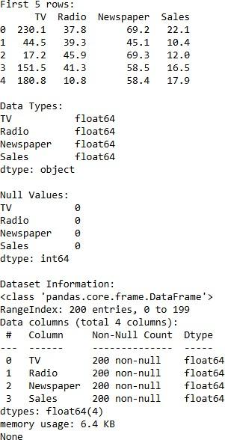
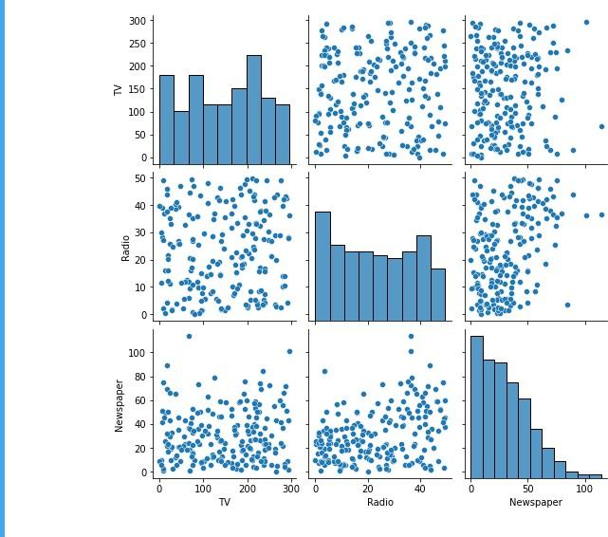
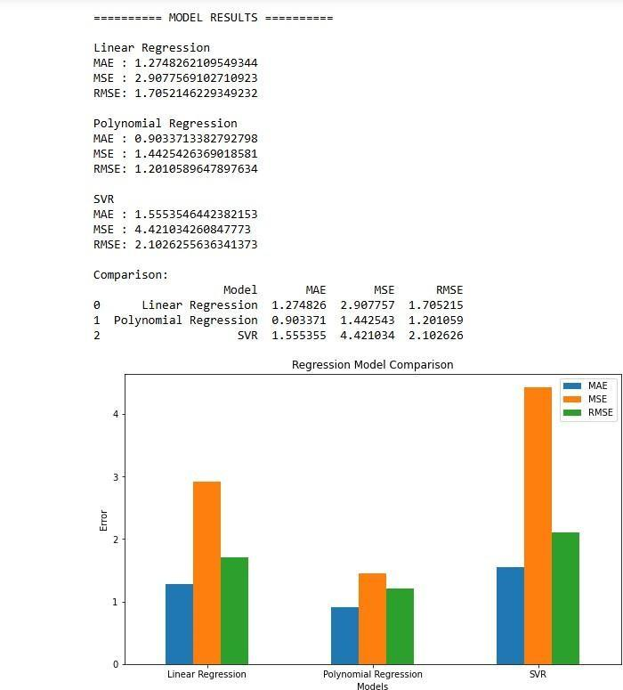
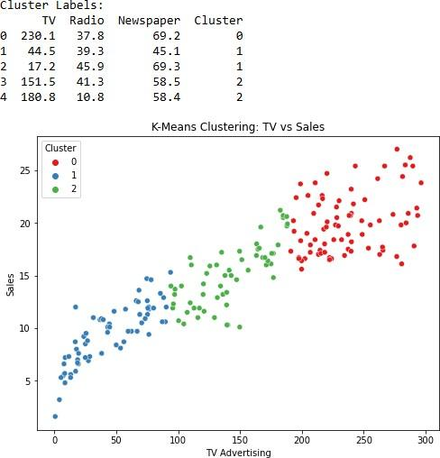

Learning Outcomes
After completing this experiment, students will be able to preprocess and split datasets for machine learning, implement Linear Regression, Polynomial Regression, and Support Vector Regression models, evaluate regression models using MAE, MSE, and RMSE metrics, compare the performance of different regression techniques, apply K-Means Clustering to group similar observations, and visualize both regression results and clustering patterns effectively.

